**Assignment -1**

**Sample Homepage with HTML and CSS**

|  |  |
| --- | --- |
| Assignment Date | 25 October 2022 |
| Student Name | Priyanka K |
| Student Roll Number | 715519104036 |
| Maximum Marks | 2 Marks |

**Question:**

Develop a sample homepage with html, CSS which should include banner, image & description about yourself and contact form.

**Solution:**

**Index.html**

<html lang="en">

<head>

<meta charset="UTF-8">

<meta http-equiv="X-UA-Compatible" content="IE=edge">

<meta name="viewport"

content="width=device-width, initial-scale=1.0">

<style>

* {

margin: 0;

padding: 0;

box-sizing: border-box;

}

body {

background-color: rgb(253, 254, 255);

display: flex;

justify-content: center;

align-items: center;

}

.full {

width: 50%;

max-width: 1000px;

min-height: 100px;

background-color: rgb(245, 239, 231);

margin: 0px;

display: grid;

grid-template-columns: 2fr 4fr;

}

.left {

position: initial;

background-color: #FCF6F5FF;

padding: 20px;

color: #89ABE3FF;

}

.right {

position: initial;

background-color: #89ABE3FF;

padding: 20px;

color: #FCF6F5FF;

}

.image, .Contact, .Skills, .Language, .Hobbies, .title,

.Summary, .Experience, .Education, .project {

margin-bottom: 30px;

}

.h2 {

background-color: rgb(4, 96, 150);

}

.btn {

display: flex;

justify-content: space-around;

}

</style>

</head>

<body>

<div class="full">

<div class="left">

<div class="image">

<img src="./assets/girl.png" alt="resume" style="width:100px;height:100px;">

</div>

<div class="Contact">

<h2>Contact</h2>

<p><b>Email id:</b>priyanka@psgitech.ac.in</p>

<p><b>Mobile no :</b>9876543210</p>

</div>

<div class="Skills">

<h2>Skills</h2>

<ul>

<li><b>Programming Languages :

Python, Java, C++</b></li>

<li><b>Frontend : HTML5, CSS3,

JavaScript, React</b></li>

<li><b>Backend : Node.js</b></li>

</ul>

</div>

<div class="Language">

<h2>Language</h2>

<ul>

<li>English</li>

<li>Tamil</li>

<li>Hindi</li>

</ul>

</div>

<div class="Hobbies">

<h2>Hobbies</h2>

<ul>

<li>Watching movies</li>

<li>Solving crossword puzzles</li>

<li>Cooking</li>

</ul>

</div>

</div>

<div class="right">

<div class="name">

<h1>PRIYANKA K</h1>

</div>

<div class="title">

<p>Associate Software Engineer</p>

</div>

<div class="Summary">

<h2>Summary</h2>

<p>To secure a challenging position in a reputable organization to expand my learning knowledge and skill</p>

</div>

<div class="Education">

<h2>Education</h2>

<table>

<tr>

<th>University/college </th>

<th>Passing year </th>

<th>percentage/cgpa</th>

</tr>

<tr>

<td>PSG</td>

<td>2023</td>

<td>9.4</td>

</tr>

<tr>

<td>PSGRKHSS</td>

<td>2019</td>

<td>91%</td>

</tr>

</table>

</div>

<div class="project">

<h2>Projects</h2><br>

<ul>

<li>

<h3>Food delivery app</h3>

<p>This project is based on java and sqlite3</p>

</li>

<br>

<li>

<h3>Time table generation web application</h3>

<p>This project is based on html and Django</p>

</li>

</ul>

</div>

<br><br>

<div class="btn">

<button style="font-size: 17px;"><a style="text-decoration: none; color:black;" href ="res.pdf" download ="resume" >Download</a></button>

<form method="get" action="./Contact.html">

<input type="submit" value="Hire Me" style="font-size: 17px;">

</form>

</div>

</div>

</div>

</body>

</html>

**Confirmation.html**

<!DOCTYPE html>

<html>

<head>

<meta charset="utf-8">

<meta name="viewport" content="width=device-width, initial-scale=1">

<title> Contact Form </title>

<link rel="stylesheet" href="./css/contact.css">

</head>

<body >

<h1>Thank you</h1>

<h2>Your contact details are confirmed</h2>

</body>

</html>

**Contact.html**

<!DOCTYPE html>

<html>

<head>

<meta charset="utf-8">

<meta name="viewport" content="width=device-width, initial-scale=1">

<title> Contact Form </title>

<link rel="stylesheet" href="./css/contact.css">

</head>

<body >

<h1>Contact Form</h1>

<form name="myform" method="post" action="Confirmation.html">

<div><label for="name">Name:</label>

<input type="text" id="name" name="name"></div>

<div><label for="email">Email:</label>

<input type="text" id="email" name="email"></div>

<div><label for="mobile">Mobile:</label>

<input type="text" id="mobile" name="mobile"></div>

<div><label for="job">Job Description:</label>

<input type="text" id="job" name="job"></div>

<button name="button" type="submit" value="OK">Submit</button>

</form>

</body>

</html>

**css**

**contact.css**

body{

display: flex;

flex-direction: column;

align-items: center;

justify-content: space-around;

height: 550px;

background: url('../assets/Background.jpeg') no-repeat center center fixed;

background-color: bisque;

background-size: cover;

overflow: hidden;

font-family: Sans-serif;

color: white;

}

form{

display: flex;

flex-direction: column;

align-items: center;

justify-content: space-between;

height: 300px;

}

div{

display:flex;

align-items:center;

justify-content:space-between;

width: 300px;

}

**styles.css**

* {

margin: 0;

padding: 0;

box-sizing: border-box;

}

body {

background-color: rgb(253, 254, 255);

display: flex;

justify-content: center;

align-items: center;

}

.full {

width: 50%;

max-width: 1000px;

min-height: 100px;

background-color: rgb(245, 239, 231);

margin: 0px;

display: grid;

grid-template-columns: 2fr 4fr;

}

.left {

position: initial;

background-color: #00203FFF;

padding: 20px;

color: #ADEFD1FF;

}

.right {

position: initial;

background-color: #ADEFD1FF;

padding: 20px;

color: #00203FFF;

}

.image, .Contact, .Skills, .Language, .Hobbies, .title,

.Summary, .Experience, .Education, .project {

margin-bottom: 30px;

}

.h2 {

background-color: rgb(4, 96, 150);

}

.btn {

display: flex;

justify-content: space-around;

}

**assets**

**man.png**



**Background.jpeg**



**Output:**

**Index:**

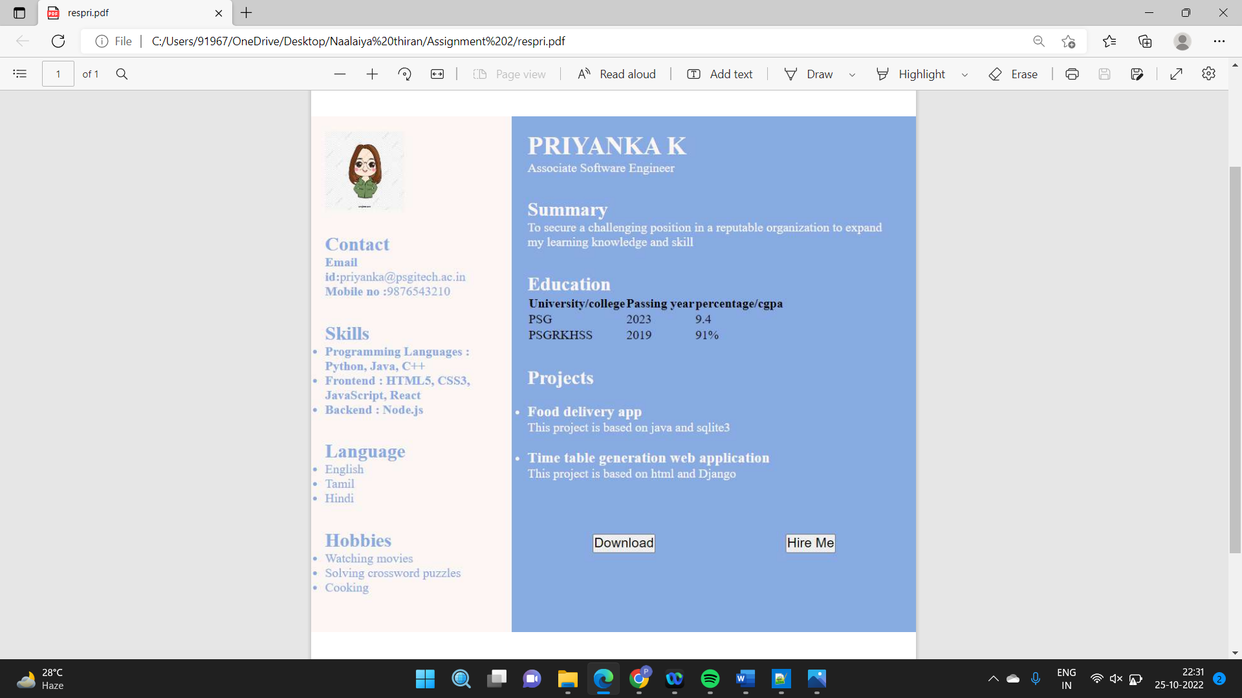

**Contact**

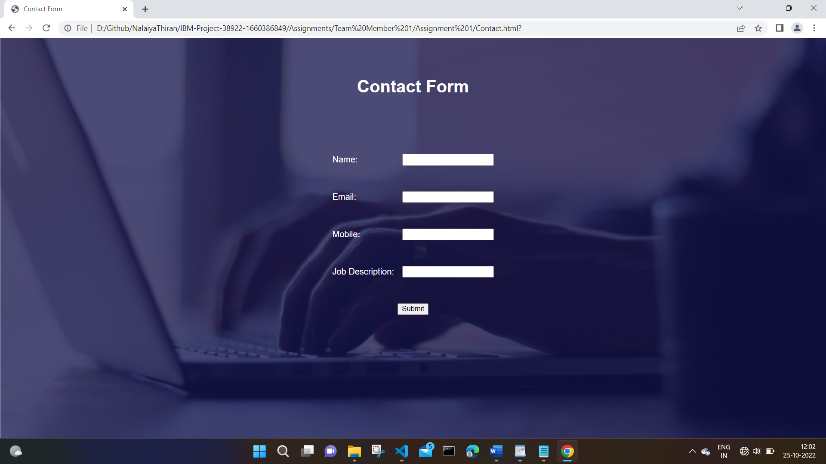

**Confirmation:**

